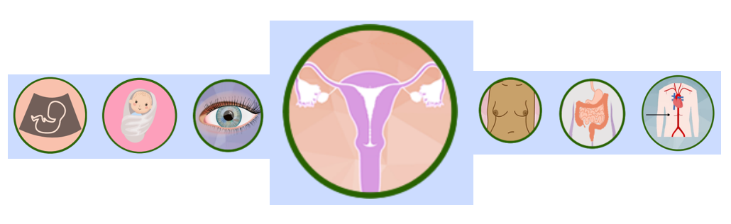

Cervical Cancer Prevention Week 19-25 January 2026
Cervical Cancer Prevention Week is an opportunity to raise awareness of how women and anyone with a cervix can look after their health and prevent cervical cancer by attending regularly for a Cervical Screening (smear) Test.
It is one of the national screening programmes that NHS Lothian Public Health Screening team oversee. Community engagement about the benefits and process of cervical screening is key to support people to take up the screening invite.
Your links with local communities, especially those eligible to attend for a cervical screening is vital to helping raise awareness by having conversations and displaying information attached. You might find the information and key messages helpful to promote this campaign but please note this document is for your reference only as a staff member or volunteer. It is intended to support opportunistic discussion and the delivery of accurate messages about screening but should not be shared with the public as an information leaflet. Public information sources are detailed at the end of the document.
Background
Cervical screening is offered routinely every 5 years to all women and those with a cervix aged 25-64 years. Cervical cancer is the most common cancer in women aged 25 to 35 years. Protecting yourself by attending regularly for cervical screening and having the HPV vaccination means that any changes can be detected early and treated to help prevent cervical cancer.
Key Messages
- Your first invite to screening will arrive when you turn 25 years old
- If you have never attended cervical screening or attended infrequently and you are between 25-64 years, it’s never too late. Call your GP practice
- Attending regular cervical screening and having your HPV vaccine are the best way to prevent cervical cancer
- Its important to attend for screening even if you are vaccinated against HPV OR are not sexually active
What’s important for people to understand?
- Cervical screening is a quick test to check your cervix for the Human Papilloma Virus (HPV). The actual test only takes 5 minutes of your appointment and can stop cancer before it starts.
- The cervix is the narrow part of the uterus (womb). It forms the connection between the uterus and the vagina.
- People who have a cervix include women, trans men, and people assigned female at birth (AFAB).
- You must register with a GP practice and update your contact details every time you move to ensure that your invite reaches you at the correct address.
- The screening invitation will be posted to your home address.
- Phone your GP surgery to make an appointment with the practice nurse – it can be rearranged at any time.
- If you are worried about attending for screening you can speak to the Practice Nurse, and they can help to answer your questions or offer the following:
  - a longer appointment
  - a visit to the clinic beforehand to see the equipment and get comfortable
  - bring someone with you for support
  - an interpreter, please contact your GP practice in advance and tell them your preferred language.
  - special arrangements for any disabilities, please contact your GP practice to discuss the support you need.
Participating in Screening is up to you - make an informed choice - make sure you have enough information to decide what is best for you.
Resources:
The Public Health Screening Team (NHS Lothian) has developed an easy read website covering all the national screening programmes, in a multitude of languages. NHS Inform Screening pages are also a useful source of information. Promoting these could help to facilitate conversations about screening. Public Health Scotland has recently developed a new resource designed for health professionals who don’t work within cervical screening, but work with individuals eligible for cervical screening Overview - Cervical screening - Disease screening - Conditions and diseases - Population health - Public Health Scotland
Public Health Scotland website will also have campaign assets which should be available the week before (19-25 Jan.)
Stand up to cancer screening checker as part of Channel 4’s Stand Up To Cancer campaign, a new Screening Checker has been launched to help people find out if they’re eligible for cancer screening.
Get Checked Early has videos, posters, and social media posts available to download raising awareness of cervical screening.
The Screening and Early Detection Team has a short promotional “snippet” on cervical screening which is part of a longer video on screening.
The HPV vaccine and cervical screening
- Missed your HPV vaccine? If you are under 25, you can still get vaccinated.
- The HPV vaccine reduces your chances of getting HPV that can be linked to certain types of cancer, but not all.
- It is offered to children aged 12-13 years old and people at higher risk of HPV.
- Regular cervical screens are still important even if you have had the HPV vaccine.
This video explains why – What’s the link between the HPV vaccine and cervical screening? (youtube.com)

